THE UNIVERSITY OF AZAD JAMMU AND KASHMIR, MUZAFFARABAD



|  |  |
| --- | --- |
| COURSE TITLE | CALD |
| COURSE CODE | CS-1205 |
| ASSIGNMENT TITLE | Adders & Subtractors |
| STUDENT NAME | Tayyab Hanif Awan |
| STUDENT ROLL NUMBER | 2024-SE-11 |
| INSTRUCTOR NAME | Engr. Sidra Rafique |
| SUBMISSION DATE | 9th August, 2025 |
| LAB NUMBER | 06 |

**Adders & Subtractors**

In digital electronics, arithmetic operations such as addition and subtraction are performed using logic circuits known as adders and subtractors. These circuits form the basic building blocks of processors and digital systems, allowing binary data to be manipulated with high speed and

precision.

**1. Full Adder**

A full adder is a combinational logic circuit that performs the addition of three binary bits: two significant bits (A and B) and a carry-in (Cin). The output consists of a Sum bit and a Carry-out (Cout) bit.

**Truth Table:**  
A | B | Cin || Sum | Cout  
0 | 0 | 0 || 0 | 0  
0 | 0 | 1 || 1 | 0  
0 | 1 | 0 || 1 | 0  
0 | 1 | 1 || 0 | 1  
1 | 0 | 0 || 1 | 0  
1 | 0 | 1 || 0 | 1  
1 | 1 | 0 || 0 | 1  
1 | 1 | 1 || 1 | 1

**Logic Expression:**  
Sum = A ⊕ B ⊕ Cin  
Cout = (A • B) + (Cin • (A ⊕ B))

**Block Diagram**

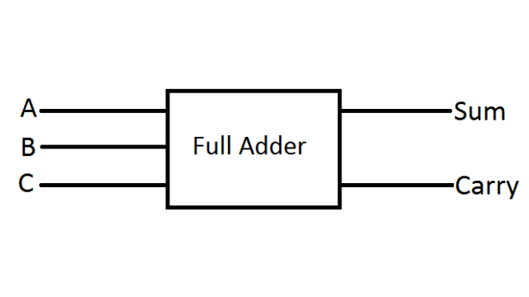

**Practical implementation**

1. **Sum**

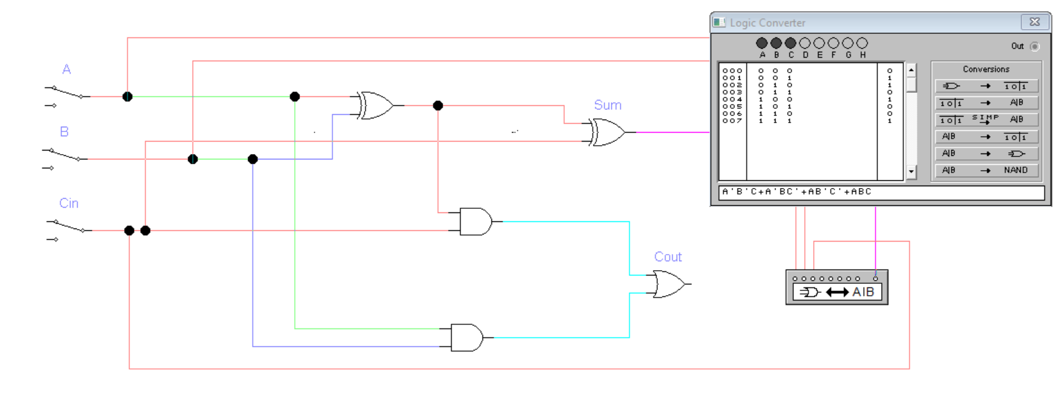

1. **Carry out:**

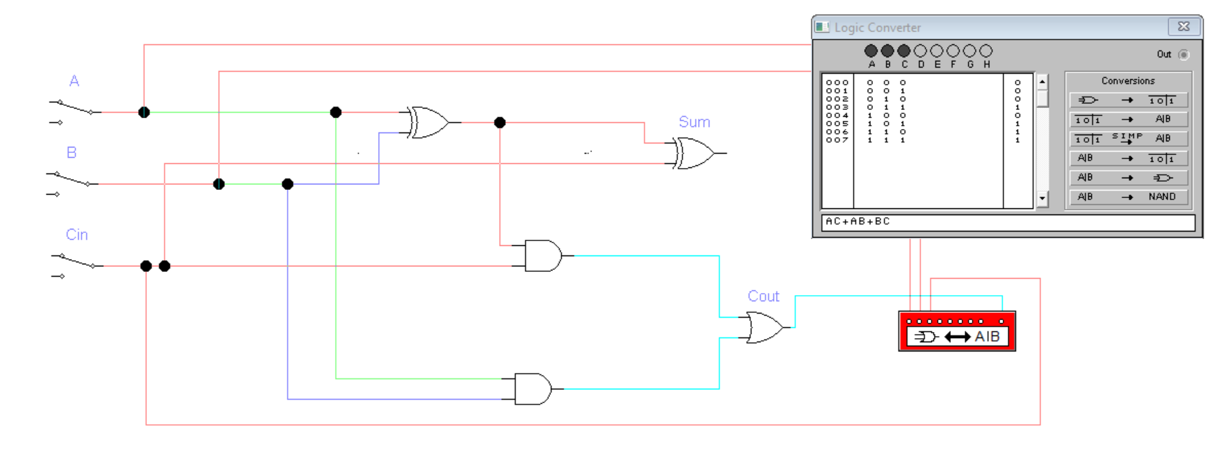

**2. Half Subtractor**

A half subtractor is a combinational circuit that performs subtraction between two binary digits. It produces two outputs: Difference and Borrow.

**Truth Table:**  
A | B || Difference | Borrow  
0 | 0 || 0 | 0  
0 | 1 || 1 | 1  
1 | 0 || 1 | 0  
1 | 1 || 0 | 0

**Logic Expression:**  
Difference = A ⊕ B  
Borrow = ¬A • B

The half subtractor does not consider borrow-in from previous stages, making it suitable for single-bit subtraction only.

**Block Diagram**

**Practical Implementation**

1. **Difference**

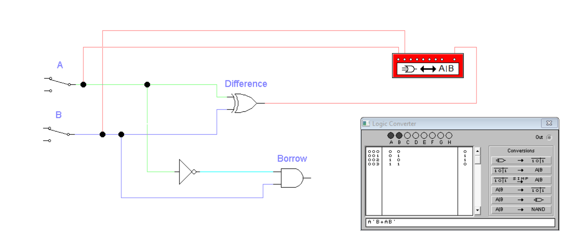

1. **Borrow**

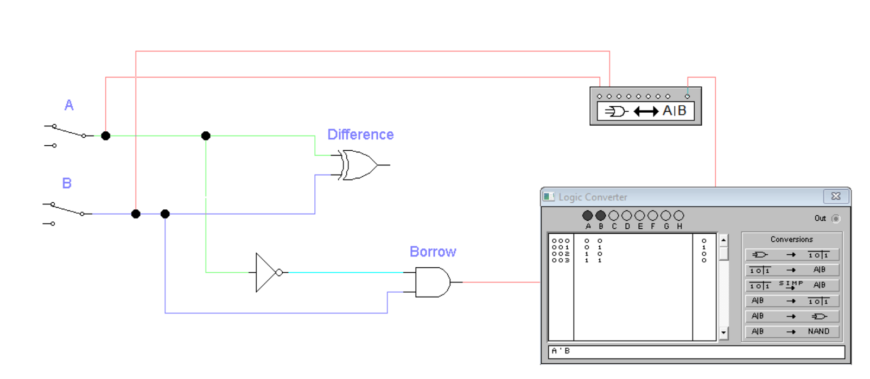

**3. Full Subtractor**

A full subtractor is a combinational circuit that performs subtraction between two binary bits while considering a borrow-in (Bin) from a previous stage. It produces Difference and Borrow-out (Bout) as outputs.

**Truth Table:**  
A | B | Bin || Difference | Bout  
0 | 0 | 0 || 0 | 0  
0 | 0 | 1 || 1 | 1  
0 | 1 | 0 || 1 | 1  
0 | 1 | 1 || 0 | 1  
1 | 0 | 0 || 1 | 0  
1 | 0 | 1 || 0 | 0  
1 | 1 | 0 || 0 | 0  
1 | 1 | 1 || 1 | 1

**Logic Expression:**Difference = A ⊕ B ⊕ Bin  
Bout = (¬A • B) + (¬(A ⊕ B) • Bin)

A full subtractor can be implemented using two half subtractors and an OR gate.

**Block Diagram**

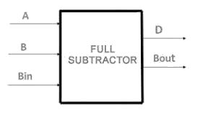

**Practical Implementation**

1. **Difference**

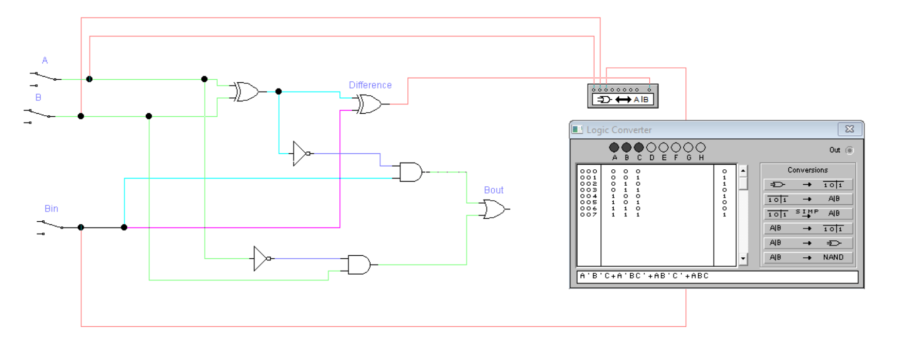

1. **Borrow**



